1. **left recursion :**

#include<stdio.h>

#include<string.h>

int main() {

char input[100],l[50],r[50],temp[10],tempprod[20],productions[25][50];

int i=0,j=0,flag=0,consumed=0;

printf("Enter the productions: ");

scanf("%1s->%s",l,r);

printf("%s",r);

while(sscanf(r+consumed,"%[^|]s",temp) == 1 && consumed <= strlen(r)) {

if(temp[0] == l[0]) {

flag = 1;

sprintf(productions[i++],"%s->%s%s'\0",l,temp+1,l);

}

else

sprintf(productions[i++],"%s'->%s%s'\0",l,temp,l);

consumed += strlen(temp)+1;

}

if(flag == 1) {

sprintf(productions[i++],"%s->e\0",l);

printf("The productions after eliminating Left Recursion are:\n");

for(j=0;j<i;j++)

printf("%s\n",productions[j]);

}

else

printf("The Given Grammar has no Left Recursion");

}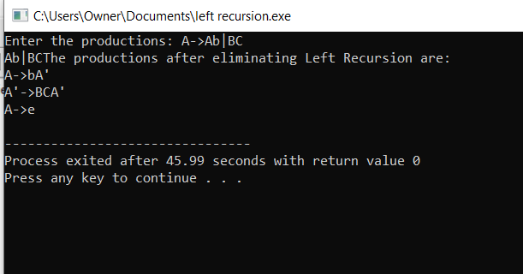

1. **left factoring output:**

#include<stdio.h>

#include<string.h>

int main()

{

char gram[20],part1[20],part2[20],modifiedGram[20],newGram[20],tempGram[20];

int i,j=0,k=0,l=0,pos;

printf("Enter Production : A->");

gets(gram);

for(i=0;gram[i]!='|';i++,j++)

part1[j]=gram[i];

part1[j]='\0';

for(j=++i,i=0;gram[j]!='\0';j++,i++)

part2[i]=gram[j];

part2[i]='\0';

for(i=0;i<strlen(part1)||i<strlen(part2);i++)

{

if(part1[i]==part2[i])

{

modifiedGram[k]=part1[i];

k++;

pos=i+1;

}

}

for(i=pos,j=0;part1[i]!='\0';i++,j++){

newGram[j]=part1[i];

}

newGram[j++]='|';

for(i=pos;part2[i]!='\0';i++,j++){

newGram[j]=part2[i];

}

modifiedGram[k]='X';

modifiedGram[++k]='\0';

newGram[j]='\0';

printf("\n A->%s",modifiedGram);

printf("\n X->%s\n",newGram);

}

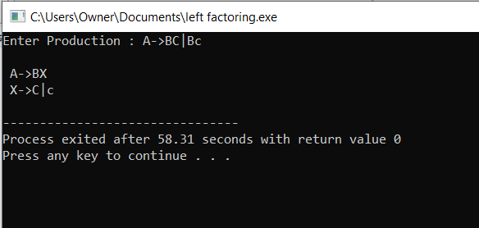

1. **symbol table:**

#include<stdio.h>

#include<stdlib.h>

#include<string.h>

int cnt=0;

struct symtab

{

char label[20];

int addr;

}

sy[50];

void insert();

int search(char *);

void display();

void modify();

int main()

{

int ch,val;

char lab[10];

do

{

printf("\n1.insert\n2.display\n3.search\n4.modify\n5.exit\n");

scanf("%d",&ch);

switch(ch)

{

case 1:

insert();

break;

case 2:

display();

break;

case 3:

printf("enter the label");

scanf("%s",lab);

val=search(lab);

if(val==1)

printf("label is found");

else

printf("label is not found");

break;

case 4:

modify();

break;

case 5:

exit(0);

break;

}

}while(ch<5);

}

void insert()

{

int val;

char lab[10];

int symbol;

printf("enter the label");

scanf("%s",lab);

val=search(lab);

if(val==1)

printf("duplicate symbol");

else

{

strcpy(sy[cnt].label,lab);

printf("enter the address");

scanf("%d",&sy[cnt].addr);

cnt++;

}

}

int search(char *s)

{

int flag=0,i; for(i=0;i<cnt;i++)

{

if(strcmp(sy[i].label,s)==0)

flag=1;

}

return flag;

}

void modify()

{

int val,ad,i;

char lab[10];

printf("enter the labe:");

scanf("%s",lab);

val=search(lab);

if(val==0)

printf("no such symbol");

else

{

printf("label is found \n");

printf("enter the address");

scanf("%d",&ad);

for(i=0;i<cnt;i++)

{

if(strcmp(sy[i].label,lab)==0)

sy[i].addr=ad;

}

}

}

void display()

{

int i;

for(i=0;i<cnt;i++)

printf("%s\t%d\n",sy[i].label,sy[i].addr);

}

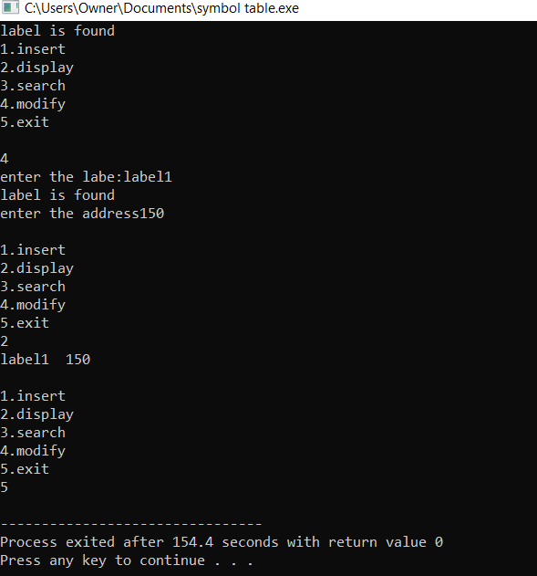

1. **recognize operators:**

#include<stdio.h>

#include<conio.h>

int main()

{

char s[5];

printf("\n Enter any operator:");

gets(s);

switch(s[0])

{

case'>':

if(s[1]=='=')

printf("\n Greater than or equal");

else

printf("\n Greater than");

break;

case'<':

if(s[1]=='=')

printf("\n Less than or equal");

else

printf("\nLess than");

break;

case'=':

if(s[1]=='=')

printf("\nEqual to");

else

printf("\nAssignment");

break;

case'!':

if(s[1]=='=')

printf("\nNot Equal");

else

printf("\n Bit Not");

break;

case'&':

if(s[1]=='&')

printf("\nLogical AND");

else

printf("\n Bitwise AND");

break;

case'|':

if(s[1]=='|')

printf("\nLogical OR");

else

printf("\nBitwise OR");

break;

case'+':

printf("\n Addition");

break;

case'-':

printf("\nSubstraction");

break;

case'*':

printf("\nMultiplication");

break;

case'/':

printf("\nDivision");

break;

case'%':

printf("Modulus");

break;

default:

printf("\n Not a operator");

}

}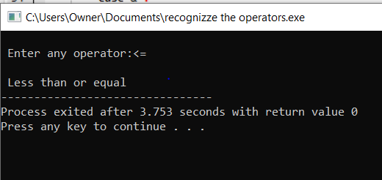

1. **recursive decent parsing:**

#include <stdio.h>

#include <string.h>

char input[100];

int i;

int E();

int EP();

int T();

int TP();

int F();

int main(void) {

printf("\nRecursive descent parsing for the following grammar\n");

printf("\nE -> TE'\nE' -> +TE'/@\nT -> FT'\nT' -> *FT'/@\nF -> (E)/ID\n");

printf("\nEnter the string to be checked:");

fgets(input, sizeof(input), stdin);

input[strcspn(input, "\n")] = '\0'; // Removing trailing newline

i = 0; // Initialize index

if (E()) {

if (input[i] == '\0')

printf("\nString is accepted");

else

printf("\nString is not accepted");

} else

printf("\nString not accepted");

return 0;

}

int E() {

if (T()) {

if (EP())

return 1;

else

return 0;

} else

return 0;

}

int EP() {

if (input[i] == '+') {

i++;

if (T()) {

if (EP())

return 1;

else

return 0;

} else

return 0;

} else

return 1;

}

int T() {

if (F()) {

if (TP())

return 1;

else

return 0;

} else

return 0;

}

int TP() {

if (input[i] == '*') {

i++;

if (F()) {

if (TP())

return 1;

else

return 0;

} else

return 0;

} else

return 1;

}

int F() {

if (input[i] == '(') {

i++;

if (E()) {

if (input[i] == ')') {

i++;

return 1;

} else

return 0;

} else

return 0;

} else if ((input[i] >= 'a' && input[i] <= 'z') || (input[i] >= 'A' && input[i] <= 'Z')) {

i++;

return 1;

} else

return 0;

**}**

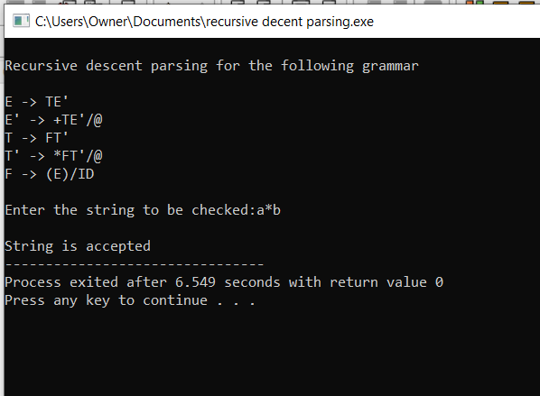

1. **comments:**

#include<stdio.h>

#include<conio.h>

int main()

{

char com[30];

int i=2,a=0;

printf("\n Enter comment:");

gets(com);

if(com[0]=='/')

{

if(com[1]=='/')

printf("\n It is a comment");

else if(com[1]=='*')

{

for(i=2;i<=30;i++)

{

if(com[i]=='*'&&com[i+1]=='/')

{

printf("\n It is a comment");

a=1;

break;

}

else

continue;

}

if(a==0)

printf("\n It is not a comment");

}

else

printf("\n It is not a comment");

}

else

printf("\n It is not a comment");

}

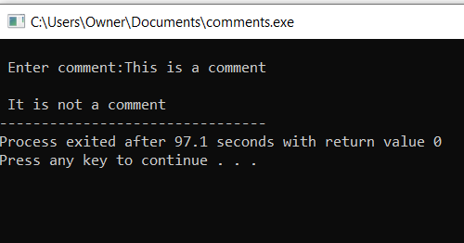

1. **id and operator output:**

#include<stdio.h>

#include<ctype.h>

#include<string.h>

int main()

{

int i,ic=0,m,cc=0,oc=0,j;

char b[30],operators[30],identifiers[30],constants[30];

printf("enter the string : ");

scanf("%[^\n]s",&b);

for(i=0;i<strlen(b);i++)

{

if(isspace(b[i]))

{

continue;

}

else if(isalpha(b[i]))

{

identifiers[ic] =b[i];

ic++;

}

else if(isdigit(b[i]))

{

m=(b[i]-'0');

i=i+1;

while(isdigit(b[i]))

{

m=m*10 + (b[i]-'0');

i++;

}

i=i-1;

constants[cc]=m;

cc++;

}

else

{

if(b[i]=='*')

{

operators[oc]='*';

oc++;

}

else if(b[i]=='-')

{

operators[oc]='-';

oc++;

}

else if(b[i]=='+')

{

operators[oc]='+';

oc++;

}

else if(b[i]=='=')

{

operators[oc]='=';

oc++;

}

}

}

printf(" identifiers : ");

for(j=0;j<ic;j++)

{

printf("%c ",identifiers[j]);

}

printf("\n constants : ");

for(j=0;j<cc;j++)

{

printf("%d ",constants[j]);

}

printf("\n operators : ");

for(j=0;j<oc;j++)

{

printf("%c ",operators[j]);

}

}

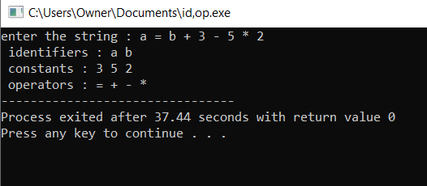

8.)In a class of Grade 3, Mathematics Teacher asked for the Acronym PEMDAS?. All of them are thinking for a while. A smart kid of the class Kishore of the class says it is Parentheses, Exponentiation, Multiplication, Division, Addition, Subtraction. Can you write a C Program to help the students to understand about the operator precedence parsing for an expression containing more than one operator, the order of evaluation depends on the order of operations.

#include<stdio.h> #include<conio.h> int main()

{

char s[5];

printf("¥n Enter any operator:");

gets(s);

switch(s[0])

{

case'>':

if(s[1]=='=')

printf("¥n Greater than or equal");

else

printf("¥n Greater than");

break; case'<':

if(s[1]=='=')

printf("¥n Less than or equal");

else

printf("¥nLess than");

break; case'=':

if(s[1]=='=')

printf("¥nEqual to");

else

printf("¥nAssignment");

break; case'!':

if(s[1]=='=')

printf("¥nNot Equal");

else

printf("¥n Bit Not"); break;

case'&':

if(s[1]=='&')

printf("¥nLogical AND");

else

printf("¥n Bitwise AND");

break; case'|':

if(s[1]=='|')

printf("¥nLogical OR");

else

printf("¥nBitwise OR");

break; case'+':

printf("¥n Addition"); break;

case'-':

printf("¥nSubstraction"); break;

case'*':

printf("¥nMultiplication"); break;

case'/':

printf("¥nDivision");

break; case'%':

printf("Modulus"); break;

default:

printf("¥n Not a operator");

}

}

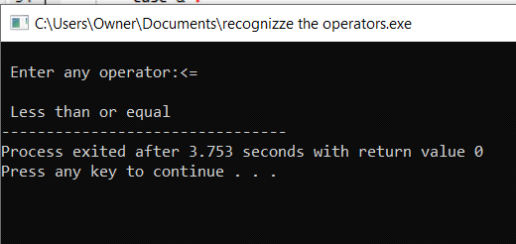

9.)#include <stdio.h> #include <ctype.h>

int main() {

char ch;

int charCount = 0, wordCount = 0, lineCount = 0; int inWord = 0;

printf("Enter text (Ctrl+D to end):¥n");

while ((ch = getchar()) != EOF) {

charCount++;

if (ch == '¥n') { lineCount++;

}

if (isspace(ch)) { inWord = 0;

} else if (!inWord) { inWord = 1; wordCount++;

}

}

// To account for the last line if it doesn't end with a newline if (charCount > 0 && ch != '¥n') {

lineCount++;

}

printf("Characters: %d¥n", charCount); printf("Words: %d¥n", wordCount); printf("Lines: %d¥n", lineCount);

return 0;

}

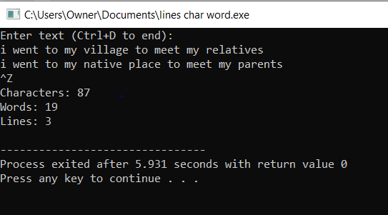

10.)#include <stdio.h> #include <string.h> #include <ctype.h> #include <stdlib.h>

int tempVarCount = 0; // Counter for temporary variables

// Function to generate a new temporary variable char* newTemp() {

static char temp[5];

sprintf(temp, "t%d", tempVarCount++); return temp;

}

// Function to print three-address code

void generateTAC(char* left, char op, char* right, char* result) { printf("%s = %s %c %s¥n", result, left, op, right);

}

// Recursive function to parse the expression and generate TAC char* parseExpression(char* expr, int start, int end) {

int i, lastOp = -1, opPosition = -1, parentheses = 0;

// Find the last operator in the expression that is outside of any parentheses

for (i = start; i <= end; i++) { if (expr[i] == '(') {

parentheses++;

} else if (expr[i] == ')') { parentheses--;

} else if (parentheses == 0 && (expr[i] == '+' || expr[i] == '-')) { lastOp = i;

} else if (parentheses == 0 && (expr[i] == '*' || expr[i] == '/') && lastOp == -1) {

opPosition = i;

}

}

if (lastOp == -1) { lastOp = opPosition;

}

if (lastOp == -1) {

if (expr[start] == '(' && expr[end] == ')') {

return parseExpression(expr, start + 1, end - 1);

} else {

char* operand = (char*)malloc(2); operand[0] = expr[start]; operand[1] = '¥0';

return operand;

}

}

char* left = parseExpression(expr, start, lastOp - 1); char* right = parseExpression(expr, lastOp + 1, end); char op = expr[lastOp];

char* result = newTemp();

generateTAC(left, op, right, result);

return result;

}

int main() {

char expr[100];

printf("Enter an arithmetic expression: ");

scanf("%s", expr);

int len = strlen(expr); parseExpression(expr, 0, len - 1);

return 0;

}

